**AUMAR: Augmented Reality-Based Mobile application for University Orientation**

**Abstract:** The transition to university life can be overwhelming for new students, especially when navigating campus environments and accessing essential resources. In response to this challenge, this study introduces AUMAR, a mobile application designed to enhance university orientation through GPS and QR code technologies. The application aims to provide seamless navigation, information retrieval, and campus exploration to new students. By leveraging GPS functionality, AUMAR offers real-time location-based services, including route guidance to academic buildings, student services, and recreational facilities. QR code integration allows users to access relevant information by scanning codes at key campus locations. This paper presents the development process of AUMAR, including its conceptual framework, design considerations, and implementation plan. Furthermore, it discusses the results of user testing and evaluation, highlighting the application's usability, effectiveness, and potential impact on university orientation. Through its innovative features and user-friendly interface, AUMAR demonstrates promise in facilitating a smoother transition for new students and optimizing their university experience.

**Keywords:** Augmented Reality (AR), Mobile application, University orientation, Navigation, Technology acceptance model (TAM), Situated learning theory, Location-based services

1. **Introduction**

Every year, hundreds of thousands of students leave college and enter university to become successful professionals. As institutions of higher learning, universities are crucial for helping students develop their intellectual capacity and prepare for the demands of the working world. In addition to imparting information, higher education aims to provide students with the life skills they need to succeed in the workplace and daily life (Attereya2021). University orientation programs serve as critical transitional experiences for new students entering higher-education institutions. Students who participated in this program often performed better academically than those who did not attend the orientation. program. Elements such as psychological support, academic understanding, and social integration are crucial for effective adaptation. Orientation not only motivates students but also helps them build solid social networks and adjust to the academic environment much better (Mohazana).

Orientation sessions are typically held before the start of an academic term and provide new students with an introduction to the university's policies, procedures, and academic requirements. These sessions may include presentations from university officials, faculty members, and student leaders. Campus tours were organized to familiarize new students with the physical layout of the campus, including academic buildings, residence halls, dining facilities, and recreational areas. These tours often highlight key campus landmarks and points of interest (POIs). Information sessions cover a wide range of topics relevant to student life, including academic advice, course registration, financial aid, campus safety, and student support services. These sessions aimed to address the common questions and concerns of new students. Resource fairs bring together various campus departments, organizations, and services to provide new students with information and resources. Students have the opportunity to learn about academic programs, extracurricular activities, health and wellness services, and campus involvement. Academic advising sessions help new students to plan their academic schedules, select courses, and set educational goals. Advisors provide guidance on degree requirements, course sequencing, and academic policy. Peer mentorship programs pair new students with experienced peers, who can offer guidance, support, and advice throughout their transition to university life. Peer mentors can assist with academic planning, campus navigation, and social integration. Orientation events and activities provide new students with opportunities to connect with their peers, build relationships, and engage in campus life. These include social gatherings, recreational outings, team-building exercises, and cultural celebrations. Many universities offer online orientation resources such as webinars, videos, and interactive modules to supplement in-person orientation sessions. These resources enable students to access information at their own pace and on their own schedule.

Orientation program costs vary significantly across regions and institutional types. In the U.S., orientation fees range from $100 to over $500 per student, with large universities such as UNCChapel Hill and Stanford charging $232 and $525, respectively. These programs often have budgets exceeding $250,000, with some reaching nearly $1 million at institutions, such as the University of Oregon. Smaller colleges may embed tuition costs or offer simpler, low-cost programs. In Canada, orientation fees average around C$90 (~US$63), with funding from a mix of student fees, university support, and sponsorship. Australia uses the Student Services and Amenities Fee (SSAF) to fund free “O-Week” events, with some universities allocating millions of student services, including orientation. In Europe, orientation is typically free and funded by universities and student unions. In Asia, India mandates a three-week induction program for engineering students, with costs borne by institutions and the government. Other Asian and African universities offer shorter academic-focused orientations with lower per-student costs. Generally, larger institutions, especially in the U.S., spend more on orientation because of larger student intakes and extensive programming, whereas smaller and non-U.S. universities adopt more modest or integrated funding models. Despite cost variability, orientation is widely recognized as a valuable investment in student success and retention.

Navigating the complexities of campus life, understanding academic requirements, and accessing essential resources can be daunting tasks for future students. Traditional orientation methods, although valuable, may not always adequately address the diverse needs and preferences of modern learners. In recent years, advancements in mobile technology have offered new avenues to enhance the orientation process. Mobile applications have emerged as powerful tools for delivering personalized and interactive experiences to students. By leveraging features such as GPS navigation and QR code scanning, mobile applications can revolutionize the way students engage with their university environments. The integration of augmented reality (AR) technology further extends the capabilities of mobile applications by offering immersive and interactive experiences that blend digital content with the physical world. By overlaying virtual information in real-world environments, AR applications can provide students with contextualized guidance, information, and engagement opportunities during university orientation. The global augmented reality market size was estimated at USD 83.65 billion in 2024 and is expected to grow at a CAGR of 37.9% from 2025 to 2030.

Implementing augmented reality (AR) for university orientation can offer numerous benefits, such as enhancing student engagement and providing immersive experiences. AR provides an interactive way for students to familiarize themselves with the campus environment, degree programs, and course curricula. This interactive approach can reduce students' fear of failure and prevent educational withdrawal by making them more comfortable with their new learning environment (Ngyuen). AR applications can significantly increase student engagement and motivation. For instance, an AR-based lab orientation application, AR-LabOr, was found to be more engaging and supportive compared to traditional methods, helping students better understand lab equipment and safety rules (Nadeem). AR can improve spatial orientation skills, which are crucial for navigating a new campus. A study showed that students using AR for landscape interpretation improved their spatial orientation skills significantly compared to those who did not use AR (Carrera)

Many universities have adopted augmented reality (AR) applications as an alternative method for campus exploration, offering students the flexibility to navigate the campus at their convenience, while simultaneously reducing institutional costs related to staff-led tours. One of the earliest implementations of AR for campus orientation was at Columbia University, which employed head-mounted displays, GPS, and orientation tracking to deliver 3D tour guide content to visitors [33]. Fu-Jen Catholic University was the first to apply AR specifically to new students, helping them familiarize themselves with the campus environment (chou2012) [34]. Similar initiatives have been developed at institutions such as Lehigh University and the University of Columbia, where AR applications were used to identify university buildings (Li2014) [35] and provide campus tours (Low2014) [36], respectively. Some systems incorporate voice-command search functionalities to help users locate and share points of interest (delail) [37]. At Bowling Green State University, AR applications have been used not only for campus navigation, but also to guide visitors to specific cultural events or locations (wong2013, Chou2014) [38,39]. At Chung Hua University, Yu et al. developed an AR-based navigation system focused on the ecological aspects of the campus, combining audio and visual information about local flora and fauna to promote environmentally friendly navigation (YU2015) [40]. Similarly, Giraldo et al. implemented a virtual AR tour at the University of Quindío (UQ) featuring a 3D directional board to guide users to various campus locations (Giraldo2016)[41]. At Mil. Nueva Granada University, Garay-Cortes, and Uribe-Quevedo designed an AR guide for new students, including landmark-triggered mini-games and a dynamic campus map (Cortes, 2016)[42]. Some AR applications allow users to access information by photographing landmarks with the system recognizing the image and displaying relevant data (Ozcan2017)[43]. At the Haaga-Helia University of Applied Sciences (UAS), Nguyen et al. developed an AR tool to support students who could not attend the orientation week, enabling them to catch up on missed information (nguyen2018)[44]. At Management and Science University (MSU), Andri created both physical and virtual AR tours. This allows users to point their smartphones on signboards to reveal concealed content, such as building descriptions, staff profiles, or cafeteria menus. Additionally, a remote viewing feature offers a 360-degree panoramic experience on campus (Andri2019) [45]. The Autonomous University of Nayarit has implemented mobile AR to support self-guided learning about campus locations. This system provides students with program details, curricula, and layout of major campus buildings (Solis2016) [46].

The motivation behind this research stems from the recognition of the challenges faced by new students during the orientation process and the potential of MAR technology to address these challenges. By developing a GPS and QR code-based AR mobile application tailored specifically for university orientation, we aim to provide incoming students with a seamless and intuitive tool for navigating campus, accessing relevant information, and fostering a sense of connection to their academic community.Through this research, we seek to explore the feasibility, effectiveness, and impact of integrating GPS and QR code technologies with AR capabilities in the context of university orientation. By addressing this gap in literature, we aim to contribute valuable insights and practical solutions to enhance the orientation experience of new students and to support their successful transition into university life.

* 1. **Research Problem and Objectives**

University orientation programs often face challenges in effectively assisting new students in navigating campus facilities, accessing relevant information, and fostering their sense of belonging. Traditional methods may not fully cater to the diverse needs and preferences of modern learners, leading to inefficiencies and gaps in the process of orientation.

The objectives of this study are as follows:

* Design and develop a mobile application that integrates GPS navigation, QR code scanning, and augmented reality (AR) features to facilitate university orientation for incoming students.
* Implement GPS-based navigation functionalities to provide real-time guidance and directions to academic buildings, student services, and key campus locations.
* Integrate AR technology to overlay virtual information into physical campus environments, allowing users to explore campus landmarks, points of interest, and relevant resources.
* QR code scanning capabilities enable users to access relevant information and resources by scanning QR codes placed at strategic locations across the campus.
* Curate and organize educational content, campus maps, event schedules, and other orientation materials within the mobile application for easy access and retrieval.
* Conduct usability testing and user feedback sessions to assess the ease of use, functionality, and user experience of GPS and QR code-based AR mobile applications.
* Measure the effectiveness of the application in supporting new students' orientation experience, including their ability to navigate campuses, access information, and engage with orientation materials.
  1. **Significance of Study**

Mobile applications allow students to access educational content anytime and anywhere by using smartphones or tablets. This level of accessibility enables flexible learning opportunities and accommodates diverse schedules and preferences. Implementing QR code scanning functionalities will empower new students to access relevant information and resources conveniently and on demand, thereby facilitating a smoother transition into university life. Augmented reality (AR) technology is used to create immersive and interactive experiences that engage new students in their campus environment, fostering a sense of connection and belonging. It provides valuable insights and practical solutions to enhance university orientation practices through the development and evaluation of a GPS and QR code-based AR mobile application.

* 1. **GPS and QR Code Technologies in Navigation Apps**

Navigation applications have become integral tools for users to navigate efficiently through physical environments. The integration of the Global Positioning System (GPS) and Quick Response (QR) code technologies in these apps has significantly enhanced their functionality, accessibility, and usability. This literature review explores the role of GPS and QR code technologies in navigation apps by examining their individual contributions, integration possibilities, and implications for the user experience.

**GPS technology in navigation applications**

GPS technology has revolutionized navigation by providing accurate positioning and location tracking capabilities. According to Cahn and Markert (2017), GPS enables the real-time tracking of user locations using satellite signals, allowing navigation apps to provide turn-by-turn directions, route optimization, and location-based services. The ubiquity of GPS-enabled smartphones has led to the widespread adoption of navigation apps such as Google Maps and Waze, which leverage GPS technology to offer seamless navigation experiences. Huang et al. (2019) highlighted the importance of GPS accuracy and reliability in navigation apps, emphasizing the need for continuous advancements in GPS technology to enhance location accuracy, particularly in urban environments with high-rise buildings and signal interference. Despite its benefits, GPS technology may face challenges, such as signal loss in dense urban areas or indoor environments, prompting researchers to explore alternative positioning methods or hybrid solutions to improve navigation accuracy (Li et al., 2018).

**2. QR Code Technology in Navigation Apps.**

QR code technology offers versatile means of encoding and retrieving information using smartphone cameras. In navigation apps, QR codes serve as digital markers that users can scan to access location-specific information, points of interest, and navigation instructions. According to a study by Hsiao et al. (2019), QR codes are commonly used in tourist navigation apps to provide contextualized information about landmarks, historical sites, and tourist attractions. Liu et al. (2017) explored the potential of QR code-based navigation systems in indoor environments, such as shopping malls, airports, and museums. QR codes placed at strategic locations within indoor spaces enable users to navigate complex environments, locate amenities, and access relevant information, without relying solely on GPS signals. This approach enhances indoor navigation experience and addresses the limitations of GPS in indoor settings.

**3. Integration of GPS and QR Code Technologies in Navigation Apps.**

The integration of GPS and QR code technologies offers synergistic benefits for navigation applications by combining real-time location tracking with on-demand information retrieval. According to Chen et al. (2020), navigation apps can utilize QR codes as supplementary navigation aids, providing users with additional context, direction, or points of interest along their route. This hybrid approach enhances the richness of navigation experiences and improves the user engagement. Recent advancements in augmented reality (AR) technology have further expanded the possibilities of GPS and QR code integration in navigation applications. AR-based navigation apps overlay digital information, such as route directions, points of interest, and location-based alerts, onto a user's real-world environment in real time. This immersive approach enhances situational awareness and facilitates intuitive navigational experiences (Kushleyev et al. 2021).

4. Implications for User Experience and Accessibility

The integration of GPS and QR code technologies into navigation apps has significant implications for user experience and accessibility. These apps enhance navigation efficiency, reduce cognitive load, and improve overall user satisfaction by providing users with accurate location information, contextualized guidance, and on-demand access to relevant information (Wu et al., 2018). However, ensuring the accessibility and usability of navigation apps for all users remains challenging. Guan et al. (2020) emphasized the importance of designing inclusive navigation interfaces that consider the diverse needs and preferences of users, including individuals with disabilities or limited mobility. Incorporating features, such as voice guidance, haptic feedback, and customizable interfaces, can enhance accessibility and usability for all users.

In conclusion, GPS and QR code technologies play crucial roles in enhancing the functionality and usability of navigation applications. The integration of these technologies offers synergistic benefits by combining real-time location tracking with on-demand information retrieval to provide users with a seamless navigation experience. Advancements in AR technology have further expanded the possibilities of GPS and QR code integration, offering immersive and intuitive navigation solutions. As navigation apps continue to evolve, researchers and practitioners must consider the diverse needs of users and strive to create inclusive and user-friendly navigation interfaces that enhance accessibility and usability.

1. **Theoretical Framework**
   1. **Conceptual Basis of AUMAR**

GPS technology allows for accurate positioning and tracking of user locations using satellite signals. By integrating GPS functionality into the app, it can determine user positions relative to their surroundings, enabling features such as real-time navigation, location-based alerts, and personalized recommendations. QR (Quick Response) codes serve as digital markers that contain the encoded information. When scanned using a smartphone camera, QR codes can quickly retrieve specific content such as website URLs, text, images, or multimedia. Integrating the QR code scanning functionality into the app enables users to access relevant information and resources by simply scanning designated QR codes placed throughout the physical environment.

AR technology superimposes digital content, such as images, videos, or 3D models, onto a real-world environment, creating an augmented view of reality. By overlaying virtual information onto physical spaces, AR enhances users' perceptions of their surroundings and enables interactive experience. In the context of the application, AR can be utilized to provide users with contextualized information, interactive guides, virtual tours, and gamified experiences that enhance their engagement and immersion within the environment.

The conceptual basis of the application involves integrating GPS, QR codes, and AR technologies synergistically to provide users with a seamless and enriched experience. GPS enables location-based services and navigation, QR codes facilitate on-demand access to information, and AR enhances the visualization and interactivity of the environment. Together, these technologies create a powerful platform for delivering personalized context-aware experiences that cater to the diverse needs and preferences of users during university orientation and beyond.

* 1. **Theoretical Perspectives on Mobile Learning and Navigation**

The theoretical framework for GPS and QR code-based Augmented Reality (AR) applications encompasses several key theoretical perspectives that inform its design, development, and implementation. The Technology Acceptance Model (TAM) provides a theoretical foundation for understanding users' acceptance and adoption of technology. By examining factors such as perceived usefulness, ease of use, and attitude toward technology, TAM helps to predict and explain users' intentions to use GPS and QR code-based AR applications. TAM insights can inform the design of user-friendly interfaces and features that align with users' needs and preferences, thereby enhancing acceptance and adoption.

Situated Learning Theory emphasizes the importance of context and social interactions in the learning process. Within the context of GPS and QR code-based AR applications, Situated Learning Theory informs the design of contextualized learning experiences situated within the physical environment. By embedding educational content, interactive challenges, and guided exploration into the user's surroundings, the application facilitates experiential learning and knowledge acquisition that are directly relevant to the user's immediate context. The Information Processing Theory focuses on how individuals acquire, process, and retain information. This theory informs the design of information retrieval mechanisms and cognitive support features in the context of GPS-and QR code-based AR applications. By optimizing the presentation of information, providing scaffolding and guidance, and incorporating interactive elements, the application enhances users' information-processing capabilities and facilitates effective learning and decision-making. User Experience (UX) design principles encompass a set of guidelines and best practices for creating intuitive, engaging, and satisfying user experiences. Drawing on principles such as simplicity, consistency, feedback, and affordance, UX design informs the design of the application interface, navigation flow, and interaction design. By prioritizing user needs, minimizing the cognitive load, and maximizing usability, the application enhances user satisfaction and engagement with the AR experience. Spatial cognition and navigation theory explore how individuals perceive, interpret, and navigate spatial environments. In the context of GPS and QR code-based AR applications, this theory informs the design of spatially aware features such as GPS-based navigation, augmented reality overlays, and landmark recognition. By leveraging users' spatial cognition abilities and providing intuitive spatial cues, the application enhances their navigation efficiency and spatial understanding within the physical environment.

1. **Methodology**
   1. **Research Design**

The research adopted a sequential exploratory design, beginning with qualitative data collection and analysis, followed by quantitative data collection and validation. This approach allows for an in-depth exploration of user experiences, preferences, and challenges before quantitatively assessing the application's performance and impact.

* 1. **Data Collection Methods**
     1. **Research Subject**

A total of 57 participants, including students (aged 19–22) and staff from the ECSE department, participated in the predesign study, and 56 participated in the post-design study. These included male, female, undergraduate, and postgraduate students. All participants were engineering students (and staff), and the majority of them belonged to the third and fourth year of an undergraduate computer and electrical engineering program. Additionally, the participants had previously experienced augmented reality in one way or another. The participants taking part in the pre-design study were not bound to take part in the post-design study; therefore, participants for both studies might or might not be the same, although it was not possible to identify them from the instrument due to anonymity.

* + 1. **Research Sample Selection**

All students and staff in ECSE who potential participants were were invited via the department mailing list to take part in the survey and were provided with a participation information sheet. The student gave consent to participate in the research by filling out a consent form and sending it to the researchers, who then contacted these participants and scheduled the time to conduct the survey. First, 60 students who provided consent were recruited to participate in this study. If a participant decided to withdraw after providing consent, the next participant was contacted. The participating students and facilitators belong to the same department (ECSE). The survey was conducted at the AUM Campus during University hours, but outside lecture hours. The participants were chosen on a first-come first-serve basis and did not receive any reward for their participation.

* + 1. **Research Procedure**

If a student was willing to participate, a meeting was scheduled with the student where only two researchers and the participant were present. The researcher conducted the evaluation and explained to the participant about the research, as mentioned in the participation information sheet and the procedure to carry out the test. The features implemented were used to explain different electrical and computer engineering concepts. The participants were provided with an Android smartphone with a lab-orientation application (AR-LabOr) pre-installed on it. Participants were informed that they were taking part voluntarily and that they could exit the study at any point without any personal consequences. Users were allowed to use the application in the vicinity of the undergraduate laboratory. Each feature of the application had a tutorial pop-up that appeared as soon as it was launched. This was done to guide students and reduce their dependency on assistance. Once the participants used the application, they were asked to complete a paper-based questionnaire evaluating its performance, comfortability, usefulness, and helpfulness. The questionnaires were created using a 5-point Likert scale to provide better understandability and easy quantification of the responses. The survey assessed how easy and intuitive the application was to use, the comparison of the AR lab orientation process with the traditional method of lab orientation, the effectiveness of the application in helping students understand the information, and the relevance of the augmented content.

* 1. **Research Ethics**

This research involved human participation and required approval from the Ethics Approval Committee. The protocol was approved by the Ethics Committee of the University of Auckland Human Participants (reference 023195). The research required interactions between students conducting the survey and the participants. Therefore, the identity of the participants was known to the researcher and anonymity was impossible. The questionnaire provided to the participants was anonymous and did not contain any information that could help identify the participants.

Apparatus

The participants could interact with the real-world FSM drawn on the handout using a smartphone and control the movement of the avatar by changing the inputs in the AR environment. The study was mostly conducted with an Android-based Samsung Galaxy S10 Wi-Fi SM-T700 16 GB model running Android 9.0 Pie with Samsung Exynos Octa-Core CPU processors, 2 × 2.73 GHz Mongoose M4 and 2 × 2.31 GHz Cor-tex-A75 and 4 × 1.95 GHz Cortex-A55, an ARM Mali-G76 MP12 GPU graphics card, and 3 GB LPDDR3 RAM. Alternatively, students could download this application from the playstore and install it on their phone. The code was also available from the GitHub repository, which could be accessed by contacting the corresponding author. We made use of the built-in technologies of the mobile for the AR system, such as the camera to capture real-world views, a touch screen for interaction, and speakers to play music. Unlike many other existing applications, the instruction contents were not fixed, and any FSM drawn on paper following the guidelines provided in the help menu could be used as instruction material.

4.5. **Questionnaire**

A short questionnaire comprising two parts was designed to evaluate the mobile AR-based application The first part used a 5-point scale, ranging from strongly disagree to strongly agree, to capture the response of participants, and the second part collected open-ended feedback in terms of likes/dislikes and suggestions. Six questions in the questionnaire focused on the quality of the application design and how easy it was to use the application as well as the learning experience of the FSM, including learning interest, engagement, active learning, level of understanding, academic outcome, and the extent to which the participants would like to have the respective learning tool applied in their class. As mentioned earlier, we based our questionnaire on TAM3 [54] to measure the rate of student acceptance of the use of the AR4FSM app. We selected and adopted the questions presented by [31]. We omitted simple technology-related questions, as these did not apply to engineering students, especially ECSE students who were tech-savvy and highly experienced. The questions in the questionnaire are listed in Table 1.

* 1. **Development Process of AUMOR**

We used an incremental development model for mobile application development, which is an iterative approach that involves breaking down a project into smaller, manageable increments or iterations. Each iteration focused on delivering a specific set of features or functionalities, allowing for continuous improvement and adaptation throughout the development process. The Begin outlines the overall goals and objectives of the mobile application. Identify the core features and functionalities that are essential for the initial release as well as any additional features that can be added in future iterations. We then prioritize features and functionalities based on their importance and impact on the app's success. Factors such as user needs, market demand, and technical complexity are considered when determining the priority of each feature. The first increment includes the most critical features necessary to create a functional version of the app. This may involve basic functionalities, such as user authentication, navigation, and core functionality. Develop and test the features included in the first step. The focus is on creating a stable and reliable foundation for the app, ensuring that the core functionalities meet the requirements and expectations of the users. Gather feedback from stakeholders, users, and usability testing sessions to evaluate the first increment. This feedback is used to identify areas for improvement and to prioritize changes for future iterations. The development process was iterated by adding new features and functionalities in subsequent increments. Each increment builds upon the previous one, gradually expanding the app's capabilities and addressing the user’s feedback and requirements. Integrate new features into the app regularly and deploy updates to users as soon as they are ready. This allows for the continuous delivery of value to users and enables rapid adaptation to changing market conditions and user needs. The app's performance and user engagement metrics are monitored to identify opportunities for optimization and refinement. Use analytics tools to track user behavior, identify usability issues, and make data-driven decisions for future iterations. As the app gains traction and user adoption increases, consider scaling up the development efforts to add more advanced features and expand the app's functionality. Continue to prioritize features based on user feedback and market demand to ensure ongoing success. An ongoing feedback loop with stakeholders, users, and the development team is maintained throughout the incremental development process. Regularly solicit feedback, gather insights, and incorporate changes to ensure that the app evolves in alignment with user needs and expectations.

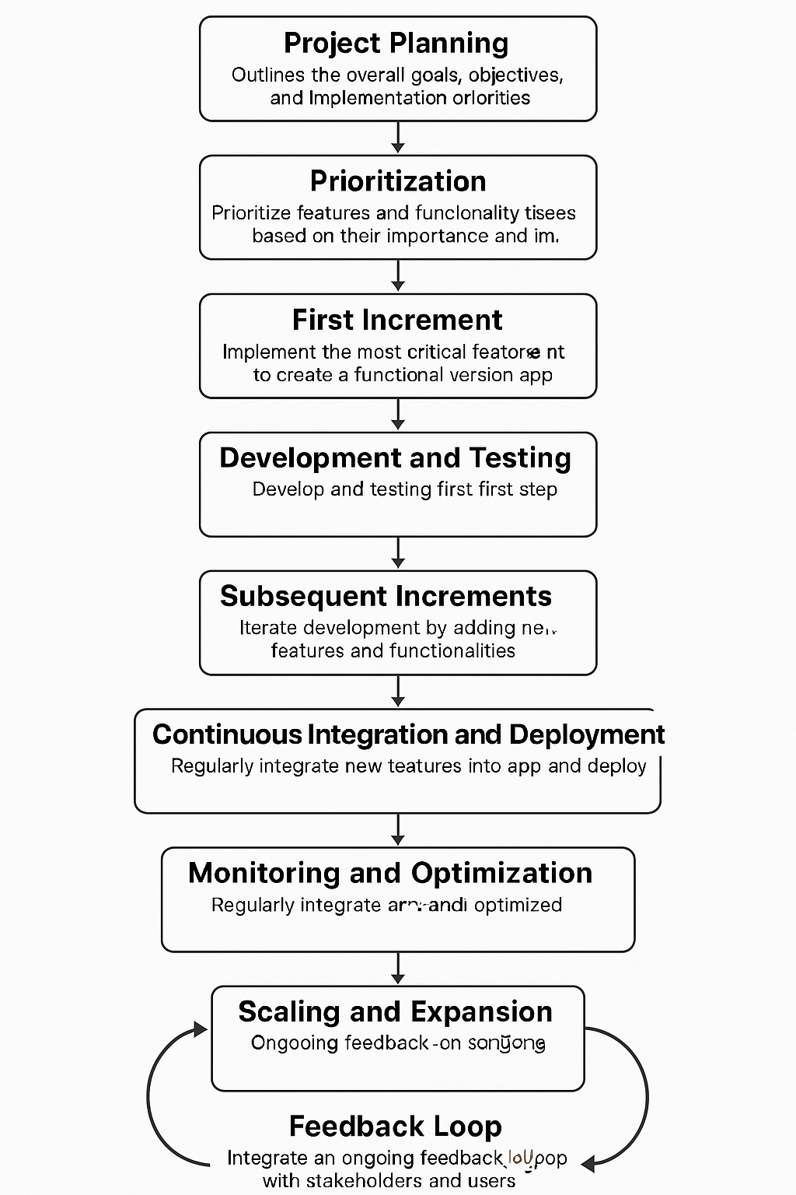

* 1. **Implementation Plan for University Orientation**

1. **Technology Overview**
   1. **AUMOR-AR architecture**

Figure 1depicts the AUMOR-AR architecture. It consists of a remote data server and a wirelessly linked mobile client application that runs on the Android operating system (OS) platform, which communicates with each other using the JSON protocol. The user engages with the application by using the camera and GPS built into the device to scan the QR code and provide the user's position, respectively. Both the camera and GPS feed their data into the AR Display, which becomes the user's interaction layer with the application. The user request, which includes GPS coordinates and scanned QR information, is structured in JSON format and sent to the remote server. This ensures interoperability and lightweight data handling. The JSON-formatted AR contents are kept on a server or repository like GitHub. The OGAR parses the JSON format that the server provides in response to this request in real time and incorporates it into the display. The globe icon on the right represents the GitHub cloud repository, which stores and serves AR content dynamically. The server parses the incoming request, matches the data with appropriate AR content, and sends a JSON-formatted response containing AR assets such as text, images, or videos. The AR content of AUMOR-AR can be updated dynamically on the server without recompiling the mobile app. This design saves time, resources, and simplifies content maintenance for developers and administrators.

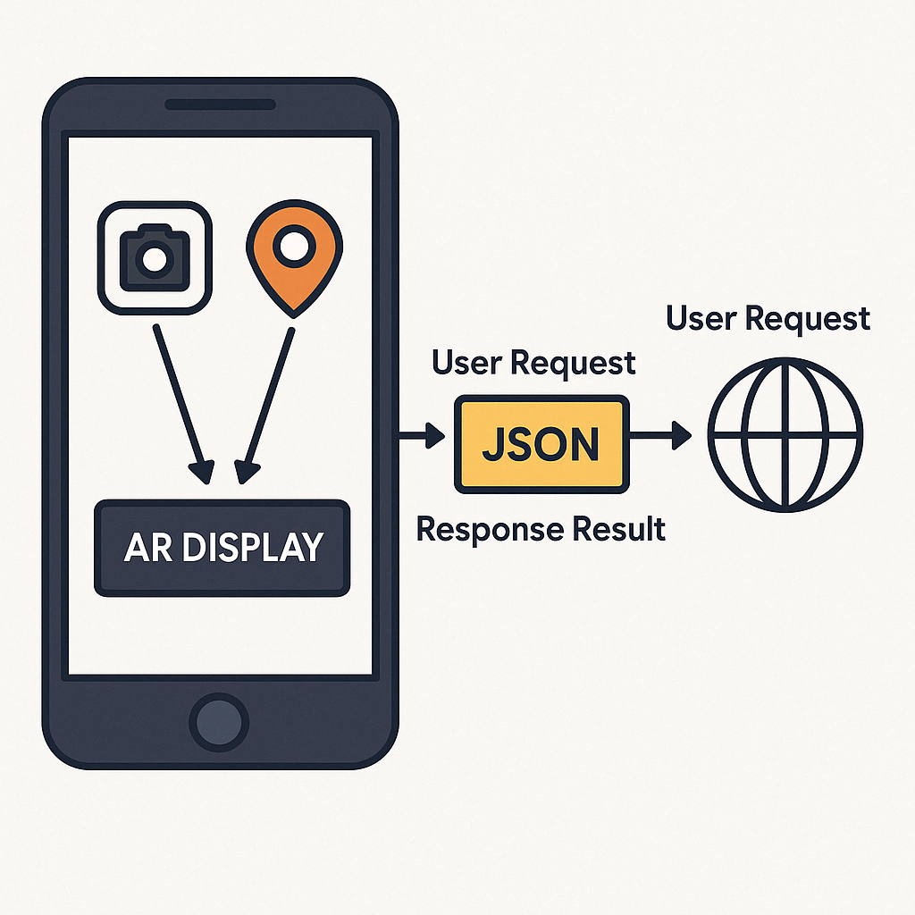

Figure 1: System architecture

* 1. **GPS Integration for Location-Based Services**
  2. **QR Code Implementation for Information Retrieval**
  3. **User Interface Design and Navigation Flow**
  4. **Augmented Reality Features and Functionality**
  5. **Application Features**
  6. **Overview of the Mobile AR Application**
  7. **User Interface Design and Navigation Flow**
  8. **Interactive AR Elements for Campus Exploration**

1. **Result**

The internal consistency of the survey is very good, with Cronbach’s Alpha of 0.927688. The total number of 128 participants is composed by 39.84% males and 60.16% females, with their current academic levels reported in *Figure 2* Most of the participants are junior (36.72%) and sophomore students (31.25%).

Figure 2: Current academic level of the survey participants.

As shown in **Figure #,** the survey participants are familiar with mobile applications, and they often (32.81%) use the apps for educational purposes. More than 35% of the participants say that sometimes they use mobile applications for educational purposes. Very few participants have never (1.56%) used mobile apps for educational purposes, or they used them rarely (4.69%).

**Figure #** Frequency of mobile application usage of the survey participants for educational purposes.

The proportion of survey participants who have used (40.63%) an AR-based application before is less than the proportion of participants who have not used it (57.03%), as provided in **Figure #.**

**Figure #** History of the usage of AR-based applications.

1. *Perceived Usefulness*

The breakdown of perceived usefulness of the AR application is shown in **Figure #**. Majority of the survey participants find the AR application useful in terms of understanding the university campus layout (60.16%) and finding useful information about campus facilities (75%) as well as in terms of overall orientation experience (57.82%). For most of the participants (74.22%) using the AR app saves time in finding important campus locations and it helps with confident campus navigation (57.03%).

**Figure #** Breakdown of the perceived usefulness of the AR application.

1. *Perceived Ease of Use*

**Figure #** shows thebreakdown of the perceived ease of use of the AR application. Most of the survey participants find information about different campus locations easily using the AR application (71.88%). They also find the AR app simple to learn and to use (70.32%), and they do not require additional instructions to understand how to use the application (49.22%). The AR app is quick in responding according to 54.68% of the survey participants, with user-friendly layout and design (66.41%), and it is not difficult to use it (52.35%).

**Figure #** Breakdown of the perceived ease of use of the AR application.

1. *Attitude Towards Use (ATU)*

The breakdown of the attitude towards the use of the AR application is shown in **Figure #**. Majority of the survey participants find the AR application a fun way to explore the campus (71.10%), and they enjoy using it (53.91%). They believe that using the AR app is a good idea for campus orientation (75.79%) and feel confident when using it to navigate though the campus (58.42%).

**Figure #** Breakdown of the attitude towards the use of the AR application.

1. *Behavioral Intention to Use (BIU)*

**Figure #** shows thebreakdown of the behavioral intention to use the AR application. The survey participants are willing to recommend the AR application to other students or new entrants (75%) and would prefer to use it over traditional methods for orientation (53.90%). Many of the survey participants (52.35%) plan to continue using the AR application during their time at the university.

**Figure #** Breakdown of the behavioral intention to use the AR application.

1. *Actual Use (AU)*

The breakdown of the usage of the different features of the AR application is shown on **Figure #**. We can observe that the survey participants used the AR app mainly for campus navigation (51.56%) and for finding information about lab equipment (39.06%). Around one third of the participants used the AR app also for finding specific buildings or departments (29.69%), gathering information on student services (28.91%) and for accessing event schedules (27.34%). Some participants were also interested in virtual tours of the campus (18.75%).

**Figure #** Breakdown of the usage of the different features of the AR application.

**Figure #** shows the frequency of the usage of the AR application during orientation. We can observe that 34.38% of the survey participants used the AR application during their orientation a few times and 17.19% of them used the AR app regularly throughout the orientation, while 10.94% used it only once.

**Figure #** Frequency of the usage of the AR application during orientation.

**Figure #** shows the intended usage of the AR application after the orientation. Most of the survey participants are likely or very likely to continue using the AR application after the orientation (57.03%).

**Figure #** Intended usage of the AR application after the orientation

1. **Discussion**
   1. **Interpretation of Evaluation Results**
   2. **Strengths and Weaknesses of AUMAR**
   3. **Implications for University Orientation Practices**
2. **Conclusion**
   1. **Summary of Key Findings**
   2. **Contributions to Knowledge**

Researching GPS and QR code-based AR applications for university orientation contributes to the advancement of knowledge in the field of educational technology. Researchers can explore innovative approaches to enhancing student orientation experiences and contribute to the growing body of literature on immersive learning environments. Practitioners in student services and orientation offices can leverage the findings of the study to enhance their orientation programs. They can integrate GPS and QR code-based AR applications into their existing orientation activities, providing students with immersive and interactive experiences that promote engagement and connection. Improved Student Engagement: By incorporating technology-enhanced orientation activities, practitioners can improve student engagement and satisfaction with the orientation process. AR applications offer opportunities for creative and interactive learning experiences that appeal to today's digitally savvy students.

* 1. **Future Directions for Research and Development**

**References**

**Appendices**

**Sample Screenshots of AUMAR**

**Questionnaire Used in User Testing**

**Technical Documentation for Developers**